ICT Project Report
Gold Fitness Gym
Team members:
25M-0547 M. Usman Saleem
25M-3001 Ahmad Abdullah
25M-0536 Reeja Sohail

script.js
function show_nav() {
document.getElementById("nav-links").classList.toggle("display-none");
}

function my_js_function() {
const name= document.getElementById("yourname").value;
const email = document.getElementById("email").value;
const contactNo = document.getElementById("contact").value;
const message = document.getElementById("txtmsg").value;

// Radio button checks
const gotAnswersYes = document.getElementById("answer1").checked;
const gotAnswersNo = document.getElementById("answer2").checked;
const satisfiedYes = document.getElementById("satisfied1").checked;
const satisfiedNo = document.getElementById("satisfied2").checked;

// 2. Validate Text/Textarea fields (basic empty check)
let isValid=true;
if (name == "") {
alert("Please enter your Name.");
isValid=false;
}
if (email == "") {
alert("Please enter your Email Address.");
isValid=false;
}
if (contactNo == "") {
alert("Please enter your Contact No.");
isValid=false;
}
if (message == "") {
alert("Please enter your Feedback/Message.");
isValid=false;
}

// 3. Validate Radio Button Groups
if (!gotAnswersYes && !gotAnswersNo) {
alert("Please answer the 'Did you get all your answers?' question.");
isValid=false
}

if (!satisfiedYes && !satisfiedNo) {
alert("Please answer the 'Are you satisfied with our services?' question.");
isValid = false;
}

// 4. Handle Errors or Success
if (isValid) {
alert("Form submitted successfully!");
return true;
}

return false;
}

const counters = document.querySelectorAll('.counter');
let started = false;

window.addEventListener('scroll', () => {
let sectionTop = document.querySelector('.counter-section').offsetTop;

if (window.scrollY + window.innerHeight > sectionTop && !started) {
counters.forEach(counter => {
let target = +counter.getAttribute("data-target");
let count = 0;

let speed = target / 100; // Smooth speed

let interval = setInterval(() => {
if (count < target) {
count += Math.ceil(speed);
counter.innerText = count;
} else {
counter.innerText = target;
clearInterval(interval);
}
}, 20);
});
started = true;
}
});

style.css
@import url('https://fonts.googleapis.com/css2?family=Poppins:ital,wght@0,100;0,200;0,300;0,400;0,500;0,600;0,700;0,800;0,900;1,100;1,200;1,300;1,400;1,500;1,600;1,700;1,800;1,900&display=swap');

html {
scroll-behavior: smooth;
}

body {
margin: 0;
padding: 0;
min-height: 100vh;
display: flex;
flex-direction: column;
font-family: "Poppins", sans-serif;
/* font-family: sans-serif; */
font-weight: 400;
font-style: normal;
}

header {
background-color: #0F0F0F;
display: flex;
padding: 12px 60px;
}

#business-name-container {
color: #ffd000;
display: flex;
place-items: center;
width: 33%;
}

#logo-container {
width: 33%;
display: flex;
justify-content: center;
}

#logo {
height: 130px;
}

#nav-container {
width: 33%;
display: flex;
justify-content: end;
align-items: center;
position: relative;
cursor: pointer;
}

#menu-icon {
border-radius: 8px;
padding: 4px;
}

#menu-icon:hover {
filter: invert(40%);
}

hr {
border: 1px solid #ffd000;
margin: 0px;
}

nav {
position: absolute;
top: 144px;
margin: 0;
flex-direction: column;
}

nav div {
background-color: #0F0F0F;
border-bottom: #ffd000;
border-bottom: 1px solid #ffd000;
padding: 12px;
}

nav div a {
color: #ffd000;
}

.display-none {
display: none;
}

footer {
margin-top: auto;
background-color: #0F0F0F;
color: #ffd000;
}

footer img {
width: 32px;
}

#socials {
padding: 24px;
}

#socials h2 {
margin-top: 0;
}

#socials a {
margin-right: 4px;
}

.btn {
background-color: #ffd000;
color: black;
padding: 12px 30px;
text-decoration: none;
font-size: 20px;
letter-spacing: 1.5px;
}

index.html
<!DOCTYPE html>
<html lang="en">

<head>
<meta charset="UTF-8">
<meta name="viewport" content="width=device-width, initial-scale=1.0">
<title>Gold Fitness - The Best Gym in Multan</title>
<link rel="stylesheet" href="./style.css">
<style>

.hero {
display: grid;
grid-template-columns: 50% 50%;
place-items: center;
min-height: 600px;
width: 80%;
margin: auto;
}

.choose {
display: grid;
grid-template-columns: 50% 50%;
place-items: center;
min-height: 600px;
width: 80%;
margin: auto;
}

ul {
list-style-image: url('./images/right-arrow.png');
}
</style>
</head>

<body>
<!-- header -->
<header>
<div id="business-name-container">
<h1>Gold Fitness Gym</h1>
</div>
<a href="./index.html" id="logo-container">
<img id="logo" src="./images/logo.png" alt="logo">
</a>
<div id="nav-container" onclick="show_nav();">
<img src="./images/menu.png" id="menu-icon" alt="menu" width="40px">
<nav id="nav-links" class="display-none">
<div>
<a href="./about.html">About us</a>
</div>
<div>
<a href="./products.html">Products</a>
</div>
<div>
<a href="./services.html">Our services</a>
</div>
<div>
<a href="./contact.html">Contact us</a>
</div>
<div>
<a href="./feedback.html">Give feedback</a>
</div>
</nav>
</div>
</header>
<hr>

<!-- hero container -->
<div class="containers" style="background-color: black;">
<div class="hero">
<div>
<h1 style="color: white;">It's time to man up!</h1>
<h2 style="color: #ffd000;">Join our gym today.</h2>
<div class="btn" style="width: 190px;">
<a href="#readmore" class="btn">Read More</a>
</div>
</div>
<div>
<img style="height: 500px;" src="./images/body_builder.jpg" alt="body builder image">
</div>
</div>
</div>

<!-- choose us container -->
<div class="containers" style="background-color: #ddd;">
<div class="choose" id="readmore">
<div>
<img style="height: 500px;" src="./images/b602461689edd82e49c706b9a13d6f34.jpg" alt="body builder image">
</div>
<div>
<h1>Why choose us?</h1>
<ul>
<li>😡 We motivate you!</li>
<li>🏋️‍♂️ We empower you!</li>
<li>💪 We transform you into a true man!</li>
<li>😎 We turn you into the TopG!</li>
</ul>
</div>
</div>
</div>

<!-- footer -->
<footer>
<hr>
<div id="socials">
<h2>Our Socials</h2>
<div id="social-links">
<a target="_blank" href="https://www.facebook.com/"><img src="./images/facebook.png"
alt="facebook social image"></a>
<a target="_blank" href="https://www.instagram.com/"><img src="./images/instagram.png"
alt="instagram social image"></a>
<a target="_blank" href="https://www.tiktok.com/"><img src="./images/tiktok.png"
alt="tiktok social image"></a>
</div>
</div>
<hr>
<div>
<p style="text-align: center;">&copy; Gold Fitness Gym | 2025</p>
</div>
</footer>

<script src="./script.js"></script>
</body>

</html>

about.html
<!DOCTYPE html>
<html lang="en">
<head>
<meta charset="UTF-8">
<meta name="viewport" content="width=device-width, initial-scale=1.0">
<title>About Us - Gold Fitness Gym</title>
</head>
<body>
<head>
<meta charset="UTF-8">
<meta name="viewport" content="width=device-width, initial-scale=1.0">
<title>Gold Fitness Gym</title>
<link rel="stylesheet" href=".\style.css">
<style>

.section {
width: 100%;
min-height: 650px;
background-color: #ddd;
}

.container {
width: 80%;
display: block;
margin: auto;
padding-top: 60px;
}

.content-section {
float: left;
width: 65%;
}

.content {
width: 100%;
float: left;
text-align: left;
padding: 0px 20px;
}

.content-section .title {
text-transform: uppercase;
font-size: 28px;
}

.content-section content h3 {
margin-top: 10px;
color: #d80000;
font-size: 21px;
}

.content-section .content p {
font-family: sans-serif;
font-size: 18px;
color: #3d3d3d;
margin-top: 10px;
}

.content-section .title h1 {
margin-left: 50px;
}

.content-section .content .button {
margin-top: 30px;
}

.content-section .content .button a {
background-color: #ffd000;
padding: 12px 30px;
text-decoration: none;
color: #000;
font-size: 20px;
letter-spacing: 1.5px;
}

.content-section .content .button a:hover {
background-color: #ffd000b9;
}

.image-section {
width: 30%;
float: right;
}

.image-section img {
width: auto;
height: 500px;
}
</style>
</head>

<body>
<!-- header -->
<header>
<div id="business-name-container" style="text-align: center;">
<h1>Gold Fitness Gym</h1>
</div>
<a href="./index.html" id="logo-container">
<img id="logo" src="./images/logo.png" alt="logo">
</a>
<div id="nav-container" onclick="show_nav();">
<img src="./images/menu.png" id="menu-icon" alt="menu" width="40px">
<nav id="nav-links" class="display-none">
<div>
<a href="./index.html">Home Page</a>
</div>
<div>
<a href="./about.html">About us</a>
</div>
<div>
<a href="./products.html">Products</a>
</div>
<div>
<a href="./services.html">Our services</a>
</div>
<div>
<a href="./contact.html">Contact us</a>
</div>
<div>
<a href="./feedback.html">Give feedback</a>
</div>
</nav>
</div>
</header>
<hr>

<!-- main body -->
<div class="section">
<div class="container">
<div class="content-section">
<div class="title">
<h1>About Us</h1>
</div>
<div class="content">
<h2>Today's pain is tommorow's strength.</h3>
<h3>Make your body perfect.</h4>
<p>Ever thought that you wanted to succeed in life? Ever thought that you are lacking something in life? That something is the bridge between you and your dream.
The only hurdle between you and your success is you youself.
Join Gold Fitness Gym today and start your journey towards a healthier and fitter you. We motivates you
to push your limits and achieve your fitness goals. Our state-of-the-art equipment, experienced trainers,
and supportive community will help you every step of the way. Don't wait for tomorrow, start today!
</p>
<div class="button">
<a href="./contact.html">Contact us</a>
</div>
</div>
</div>
<div class="image-section">
<img src="https://i.pinimg.com/564x/51/e6/5a/51e65a53e4b40557135bc82a29c1b055.jpg">
</div>
</div>
</div>

<!-- footer -->
<footer>
<hr>
<div id="socials">
<h2>Our Socials</h2>
<div id="social-links">
<a target="_blank" href="https://www.facebook.com/"><img src="./images/facebook.png" alt="facebook social image"></a>
<a target="_blank" href="https://www.instagram.com/"><img src="./images/instagram.png" alt="instagram social image"></a>
<a target="_blank" href="https://www.tiktok.com/"><img src="./images/tiktok.png" alt="tiktok social image"></a>
</div>
</div>
<hr>
<div>
<p style="text-align: center;">&copy; Gold Fitness Gym | 2025</p>
</div>
</footer>

<script src="./script.js"></script>

</body>
</html>

contact.html
<!DOCTYPE html>
<html lang="en">

<head>
<meta charset="UTF-8">
<meta name="viewport" content="width=device-width, initial-scale=1.0">
<title>Contact Us - Gold Fitness Gym</title>
<link rel="stylesheet" href="./style.css">
<style>
.section {
width: 100%;
min-height: 650px;
background-color: #ddd;
}

.container {
width: 80%;
display: block;
margin: auto;
padding-top: 60px;
}

.content-section {
float: left;
width: 65%;
}

.content {
width: 100%;
float: left;
text-align: left;
padding: 0px 20px;
}

.content-section .title {
text-transform: uppercase;
font-size: 28px;
}

.content-section content h3 {
margin-top: 10px;
color: #d80000;
font-size: 21px;
}

.content-section .content p {
font-family: sans-serif;
font-size: 18px;
color: #3d3d3d;
margin-top: 10px;
}

.content-section .title h1 {
margin-left: 50px;
}

.content-section .content .button {
margin-top: 30px;
}

.content-section .content .button a {
background-color: #ffd000;
padding: 12px 30px;
text-decoration: none;
color: #000;
font-size: 20px;
letter-spacing: 1.5px;
}

.content-section .content .button a:hover {
background-color: #ffd000b9;
}

.google-maps-section {
width: 30%;
float: right;
height: 500px;
}
</style>
</head>

<body style="margin: 0px; background-color: #ddd;">
<!-- header -->
<header>
<div id="business-name-container">
<h1>Contact Us</h1>
</div>
<a href="./index.html" id="logo-container">
<img id="logo" src="./images/logo.png" alt="logo">
</a>
<div id="nav-container" onclick="show_nav();">
<img src="./images/menu.png" id="menu-icon" alt="menu" width="40px">
<nav id="nav-links" class="display-none">
<div>
<a href="./index.html">Home Page</a>
</div>
<div>
<a href="./about.html">About us</a>
</div>
<div>
<a href="./products.html">Products</a>
</div>
<div>
<a href="./services.html">Our services</a>
</div>
<div>
<a href="./contact.html">Contact us</a>
</div>
<div>
<a href="./feedback.html">Give feedback</a>
</div>
</nav>
</div>
</header>
<hr>

<!-- main body -->
<div class="section">
<div class="container">
<div class="content-section">
<div class="title">
<h1>Contact Us</h1>
</div>
<div class="content">
<h2>Visit us from 11:00 AM to 11:00 PM</h3>
<p>Couldn't get the info you wanted? We are here to listen your queries. Contact us at
the
given above time availing following methods:</p>
<div class="button">
<a href="mail:goldfitness@gym.com">Mail us at goldfitness@gym.com</a>
</div>
<div class="button">
<a href="tel:+923336669966">Or call us at +92 333 3139867</a>
</div>
</div>
</div>
<iframe class="google-maps-section" frameborder="0"
src="https://maps.google.com/maps?hl=en&q=multan%20Gold%20fitness%20gym%20multan&t=&z=14&ie=UTF8&iwloc=B&output=embed"></iframe>

</div>
</div>

<!-- footer -->
<footer>
<hr>
<div id="socials">
<h2>Our Socials</h2>
<div id="social-links">
<a target="_blank" href="https://www.facebook.com/"><img src="./images/facebook.png"
alt="facebook social image"></a>
<a target="_blank" href="https://www.instagram.com/"><img src="./images/instagram.png"
alt="instagram social image"></a>
<a target="_blank" href="https://www.tiktok.com/"><img src="./images/tiktok.png"
alt="tiktok social image"></a>
</div>
</div>
<hr>
<div>
<p style="text-align: center;">&copy; Gold Fitness Gym | 2025</p>
</div>
</footer>

<script src="./script.js"></script>
</body>

</html>

feedback.html
<!DOCTYPE html>
<html lang="en">

<head>
<meta charset="UTF-8">
<meta name="viewport" content="width=device-width, initial-scale=1.0">
<title>Customer Feedback Form</title>
<link rel="stylesheet" href=".\style.css">
<style>

.container {
background-color: #ddd;
padding: 60px 0px;
}

.feedback-form {
width: 40%;
margin: auto;
}

input[type="text"], textarea {
width: 100%;
padding: 12px 15px;
}

.feedback-form h2 {
text-align: center;
color: black;
margin-bottom: 30px;
}

.feedback-form .feedback {
width: 50%;
border: none;
border-radius: 1rem;
padding: 1.5%;
background: #242421;
color: #fff;
font-size: 20px;
}
</style>
</head>

<body>
<!-- header -->
<header>
<div id="business-name-container">
<h1>Gold Fitness Gym</h1>
</div>
<a href="./index.html" id="logo-container">
<img id="logo" src="./images/logo.png" alt="logo">
</a>
<div id="nav-container" onclick="show_nav();">
<img src="./images/menu.png" id="menu-icon" alt="menu" width="40px">
<nav id="nav-links" class="display-none">
<div>
<a href="./index.html">Home Page</a>
</div>
<div>
<a href="./about.html">About us</a>
</div>
<div>
<a href="./products.html">Products</a>
</div>
<div>
<a href="./services.html">Our services</a>
</div>
<div>
<a href="./contact.html">Contact us</a>
</div>
<div>
<a href="./feedback.html">Give feedback</a>
</div>
</nav>
</div>
</header>
<hr>
<div class="container">
<form action="./thankyou.html" method="post" class="feedback-form" onsubmit="return my_js_function()">
<h2>Drop Us a Feedback</h2>
<div class="form-group">
<input type="text" id="yourname" class="form-control" placeholder="Your Name" required><br><br>
<input type="text" id="email" class="form-control" placeholder="Enter Email Address" required><br><br>
</div>
<div class="form-group">
<input type="text" id="contact" class="form-control" placeholder="Your Contact no" required >
</div>
<div class="form-group">
<div>
<p>Which service you have used:</p>
<input type="checkbox" id="membership">
<label for="membership">Membership Plan</label><br>
<input type="checkbox" id="program" >
<label for="program">Fitness Programs</label><br>
<input type="checkbox" id="info" >
<label for="info">Faculty Information</label><br>
<input type="checkbox" id="support">
<label for="support">Customer Support</label><br>
<input type="checkbox" id="other">
<label for="other">Other</label><br>
</div>
</div>
<div class="form-group">
<p>Are you satisfied with our services?</p>
<input type="radio" name="satisfied" id="satisfied1">
<label for="satisfied1">Yes</label><br>
<input type="radio" name="satisfied" id="satisfied2">
<label for="satisfied2">No</label><br><br>
</div>

<div class="form-group">
<div>
<label>Rate Our Services</label><br>
<input type="radio" name="rating" id="rating1" value="poor">
<label for="rating1">Poor</label><br>
<input type="radio" name="rating" id="rating2" value="Average">
<label for="rating2">Average</label><br>
<input type="radio" name="rating" id="rating3" value="Good">
<label for="rating3">Good</label><br>
<input type="radio" name="rating" id="rating4" Value="Excellent">
<label for="rating4">Excellent</label><br><br>
</div>
<div>
<label>Feedback type</label>
<select required>
<option value=""> Select</option>
<option value="">Suggestion</option>
<option value="">Complaint</option>
<option value="">Appreciation</option>

</select>
</div>
<textarea name="txtMsg" id="txtmsg" style="margin: 20px 0px 0px;" class="form-control" placeholder="Your Feedback" rows="6" required></textarea>
<input type="submit" name="submit" style="margin-top: 20px;" class="btn" value="Send Feedback" style="outline: none" ;>
<input type="reset" style="margin-top: 20px;" style="outline: none" class="btn" ></button>
</div>
</form>
</div>

<!-- footer -->
<footer>
<hr>
<div id="socials">
<h2>Our Socials</h2>
<div id="social-links">
<a target="_blank" href="https://www.facebook.com/"><img src="./images/facebook.png"
alt="facebook social image"></a>
<a target="_blank" href="https://www.instagram.com/"><img src="./images/instagram.png"
alt="instagram social image"></a>
<a target="_blank" href="https://www.tiktok.com/"><img src="./images/tiktok.png"
alt="tiktok social image"></a>
</div>
</div>
<hr>
<div>
<p style="text-align: center;">&copy; Gold Fitness Gym | 2025</p>
</div>
</footer>
</form>
<script src="./script.js"></script>

</body>
</html>

services.html
<!DOCTYPE html>
<html lang="en">

<head>
<meta charset="UTF-8">
<meta name="viewport" content="width=device-width, initial-scale=1.0">
<title>Our Services - Gold Fitness Gym</title>
<link rel="stylesheet" href="./style.css">
<style>

.table {
border-bottom: none;
border: none;
}

table ,th ,td{
border: 1px none;
border-collapse: collapse;
border-top: 1px none;
}

th ,td{
padding: 18px;
font-family: "Poppins", sans-serif;
font-style: normal;
/* font-size: 20px; */
border: none;
}

</style>
</head>

<body>
<!-- header -->
<header>
<div id="business-name-container">
<h1>Gold Fitness Gym</h1>
</div>
<a href="./index.html" id="logo-container">
<img id="logo" src="./images/logo.png" alt="logo">
</a>
<div id="nav-container" onclick="show_nav();">
<img src="./images/menu.png" id="menu-icon" alt="menu" width="40px">
<nav id="nav-links" class="display-none">
<div>
<a href="./index.html">Home Page</a>
</div>
<div>
<a href="./about.html">About us</a>
</div>
<div>
<a href="./products.html">Products</a>
</div>
<div>
<a href="./services.html">Our services</a>
</div>
<div>
<a href="./contact.html">Contact us</a>
</div>
<div>
<a href="./feedback.html">Give feedback</a>
</div>
</nav>
</div>
</header>
<hr>

<!-- main body -->
<div style="display: flex; justify-content: center; align-items: center; margin: auto; ">
<div style="padding: 40px 0px 60px;">
<h1 style="text-align: center;">Coaching Schedule</h1>
<p style="text-align: center; margin-top: 20px; margin-bottom: 10px; color: #3d3d3d">Our well trained coaches will allow you to Bulk Up! and reach you to reach your true potential</p>
<table style="margin-top: 40px;" class="table">
<tr>
<th style="border-bottom: 5px solid ; border-right: 5px solid;" >Coaches</th>
<th style="border-bottom: 5px solid ; ">Monday</th>
<th style="border-bottom: 5px solid ; ">Tuesday</th>
<th style="border-bottom: 5px solid ; ">Wednesday</th>
<th style="border-bottom: 5px solid ; ">Thursday</th>
<th style="border-bottom: 5px solid ; ">Friday</th>
<th style="border-bottom: 5px solid ; ">Saturday</th>
<th style="border-bottom: 5px solid ; ">Sunday</th>
</tr>
<tr>
<td style="border-right: 5px solid;">Usman Freakula</td>
<td>8:00-10:00</td>
<td>12:00-14:00</td>
<td>10:00-12:00</td>
<td>12:00-14:00</td>
<td>NA</td>
<td>10:00-12:00</td>
<td>18:00-20:00</td>

</tr>
<tr>
<td style="border-right: 5px solid;">Saie Haider</td>
<td>10:00-12:00</td>
<td>18:00-20:00</td>
<td>10:00-12:00</td>
<td>15:00-17:00</td>
<td>17:00-19:00</td>
<td>NA</td>
<td>18:00-20:00</td>
</tr>
<tr>
<td style="border-right: 5px solid;">Ahmad bin Tate</td>
<td>12:00-14:00</td>
<td>8:00-10:00</td>
<td>15:00-17:00</td>
<td>10:00-12:00</td>
<td>8:00-10:00</td>
<td>18:00-20:00</td>
<td>NA</td>
</tr>
<tr>
<td style="border-right: 5px solid;">Usama bin Laden</td>
<td>9:00-11:00</td>
<td>9:00-11:00</td>
<td>9:00-11:00</td>
<td>9:00-11:00</td>
<td>9:00-11:00</td>
<td>9:00-11:00</td>
<td>9:00-11:00</td>
</tr>

</table>
</div>
</div>

<!-- footer -->
<footer>
<hr>
<div id="socials">
<h2>Our Socials</h2>
<div id="social-links">
<a target="_blank" href="https://www.facebook.com/"><img src="./images/facebook.png" alt="facebook social image"></a>
<a target="_blank" href="https://www.instagram.com/"><img src="./images/instagram.png" alt="instagram social image"></a>
<a target="_blank" href="https://www.tiktok.com/"><img src="./images/tiktok.png" alt="tiktok social image"></a>
</div>
</div>
<hr>
<div>
<p style="text-align: center;">&copy; Gold Fitness Gym | 2025</p>
</div>
</footer>

<script src="./script.js"></script>
</body>

</html>

products.html
<!DOCTYPE html>
<html lang="en">

<head>
<meta charset="UTF-8">
<meta name="viewport" content="width=device-width, initial-scale=1.0">
<title>Our Products - Gold Fitness Gym</title>
<link rel="stylesheet" href="./style.css">
</head>

<body>
<!-- header -->
<header>
<div id="business-name-container">
<h1>Gold Fitness Gym</h1>
</div>
<a href="./index.html" id="logo-container">
<img id="logo" src="./images/logo.png" alt="logo">
</a>
<div id="nav-container" onclick="show_nav();">
<img src="./images/menu.png" id="menu-icon" alt="menu" width="40px">
<nav id="nav-links" class="display-none">
<div>
<a href="./index.html">Home Page</a>
</div>
<div>
<a href="./about.html">About us</a>
</div>
<div>
<a href="./products.html">Products</a>
</div>
<div>
<a href="./services.html">Our services</a>
</div>
<div>
<a href="./contact.html">Contact us</a>
</div>
<div>
<a href="./feedback.html">Give feedback</a>
</div>
</nav>
</div>
</header>
<hr>

<!-- main body -->
<div style="width: 80%; margin: auto;">
<h1 style="color: black; text-align: center; margin-top: 60px;">Our Products</h1>
<p style="text-align: center;">Our products are specially made to fill your bulk requirement. Members get 30% discount.</p>
<div style="display: grid; grid-template-columns: 33% 33% 33%; place-items: center;">
<div>
<img src="./images/proteinshake.png" width="300px" alt="Picture of a protein Shake">
<p style="margin: 0px; text-align: center; font-size: large;">Bulk Up! Shake</p>
</div>
<div>
<img src="./images/Proteinbar.png" width="300px" alt="Picture of a protein bar">
<p style="margin: 0px; text-align: center; font-size: large;">Bulk Up! Bar</p>
</div>
<div>
<img src="./images/Gold_big.webp" width="300px" alt="Picture of a Gold Whey">
<p style="margin: 0px; text-align: center; font-size: large;">Bulk Up! Protein Gold</p>
</div>
</div>
</div>

<!-- footer -->
<footer style="position:relative; top: 60px;">
<hr>
<div id="socials">
<h2>Our Socials</h2>
<div id="social-links">
<a target="_blank" href="https://www.facebook.com/"><img src="./images/facebook.png"
alt="facebook social image"></a>
<a target="_blank" href="https://www.instagram.com/"><img src="./images/instagram.png"
alt="instagram social image"></a>
<a target="_blank" href="https://www.tiktok.com/"><img src="./images/tiktok.png"
alt="tiktok social image"></a>
</div>
</div>
<hr>
<div>
<p style="text-align: center;">&copy; Gold Fitness Gym | 2025</p>
</div>
</footer>

<script src="./script.js"></script>
</body>

</html>

Outputs:
index.html
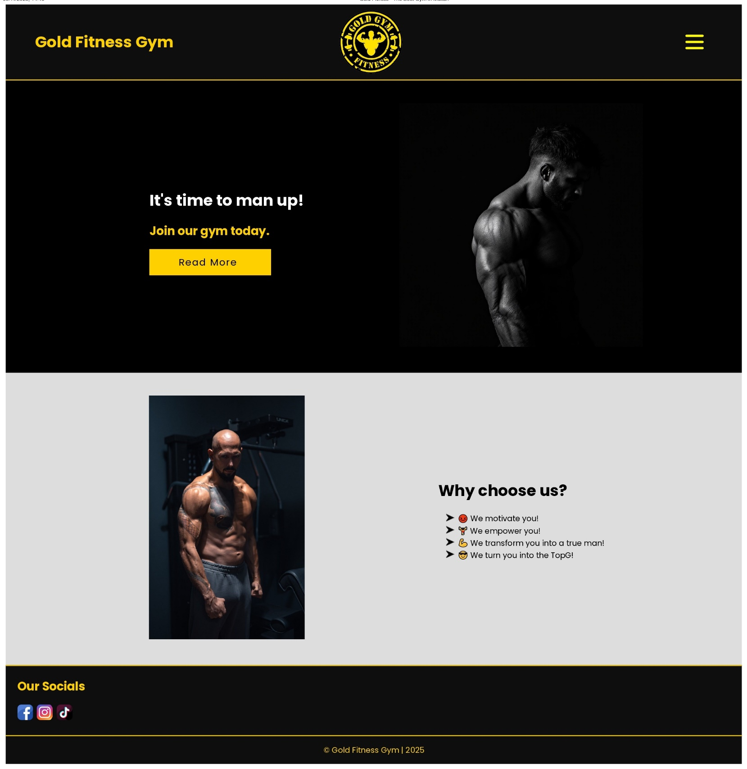

services.html
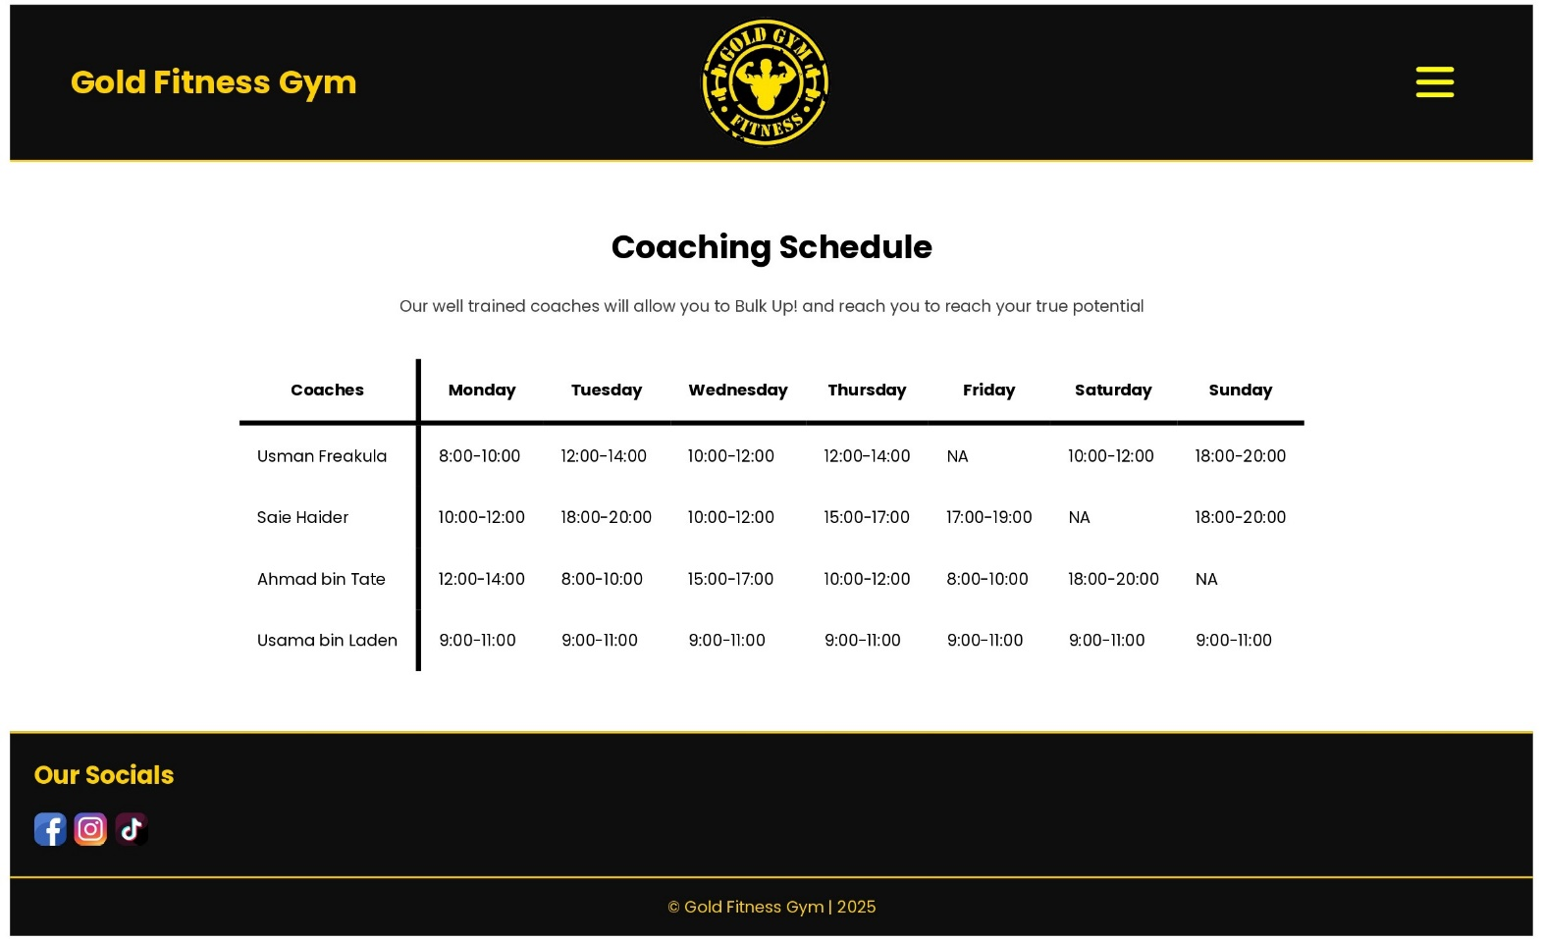
products.html
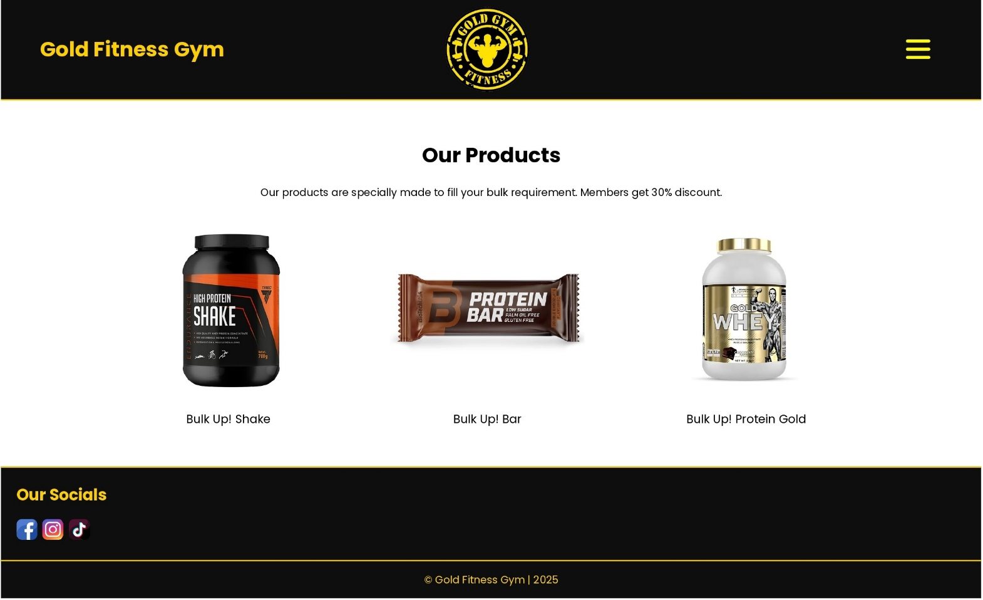
contact.html
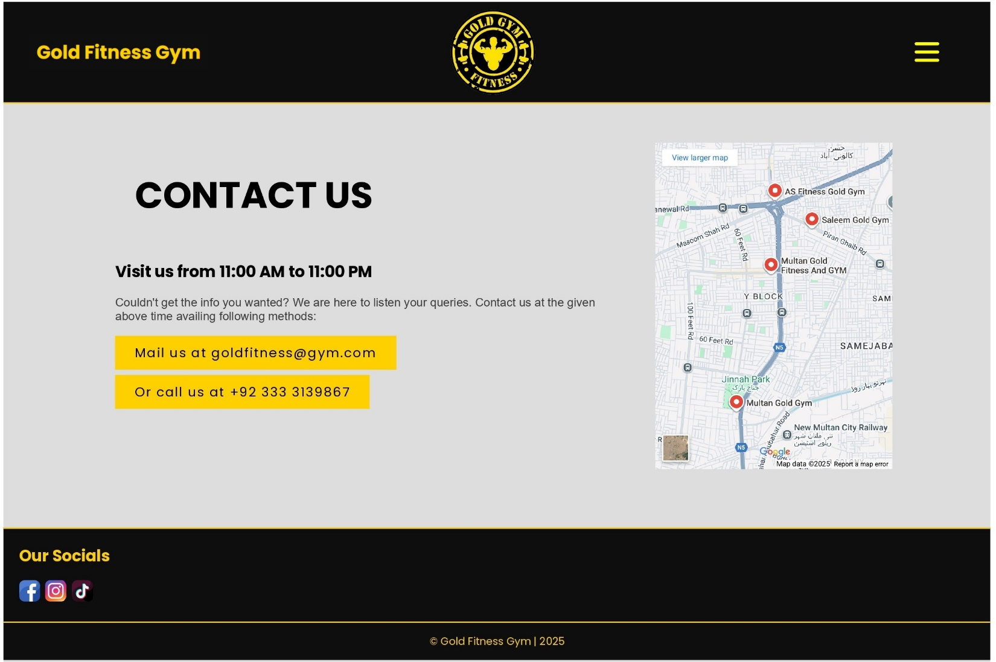

about.html
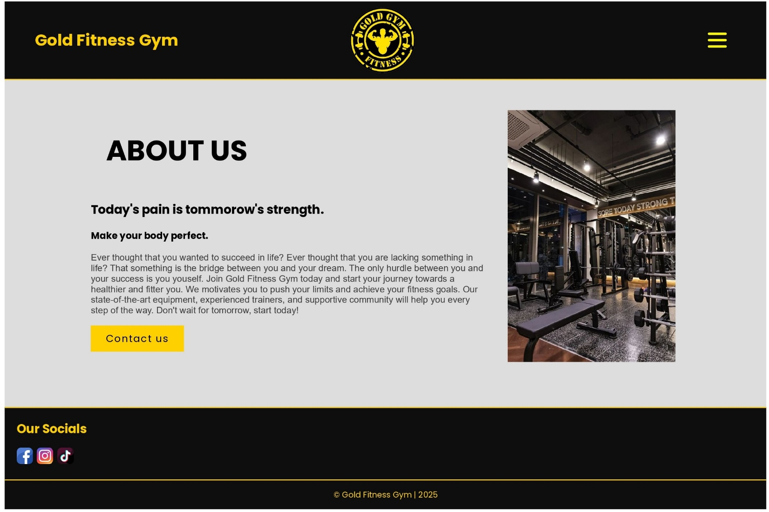

feedback.html
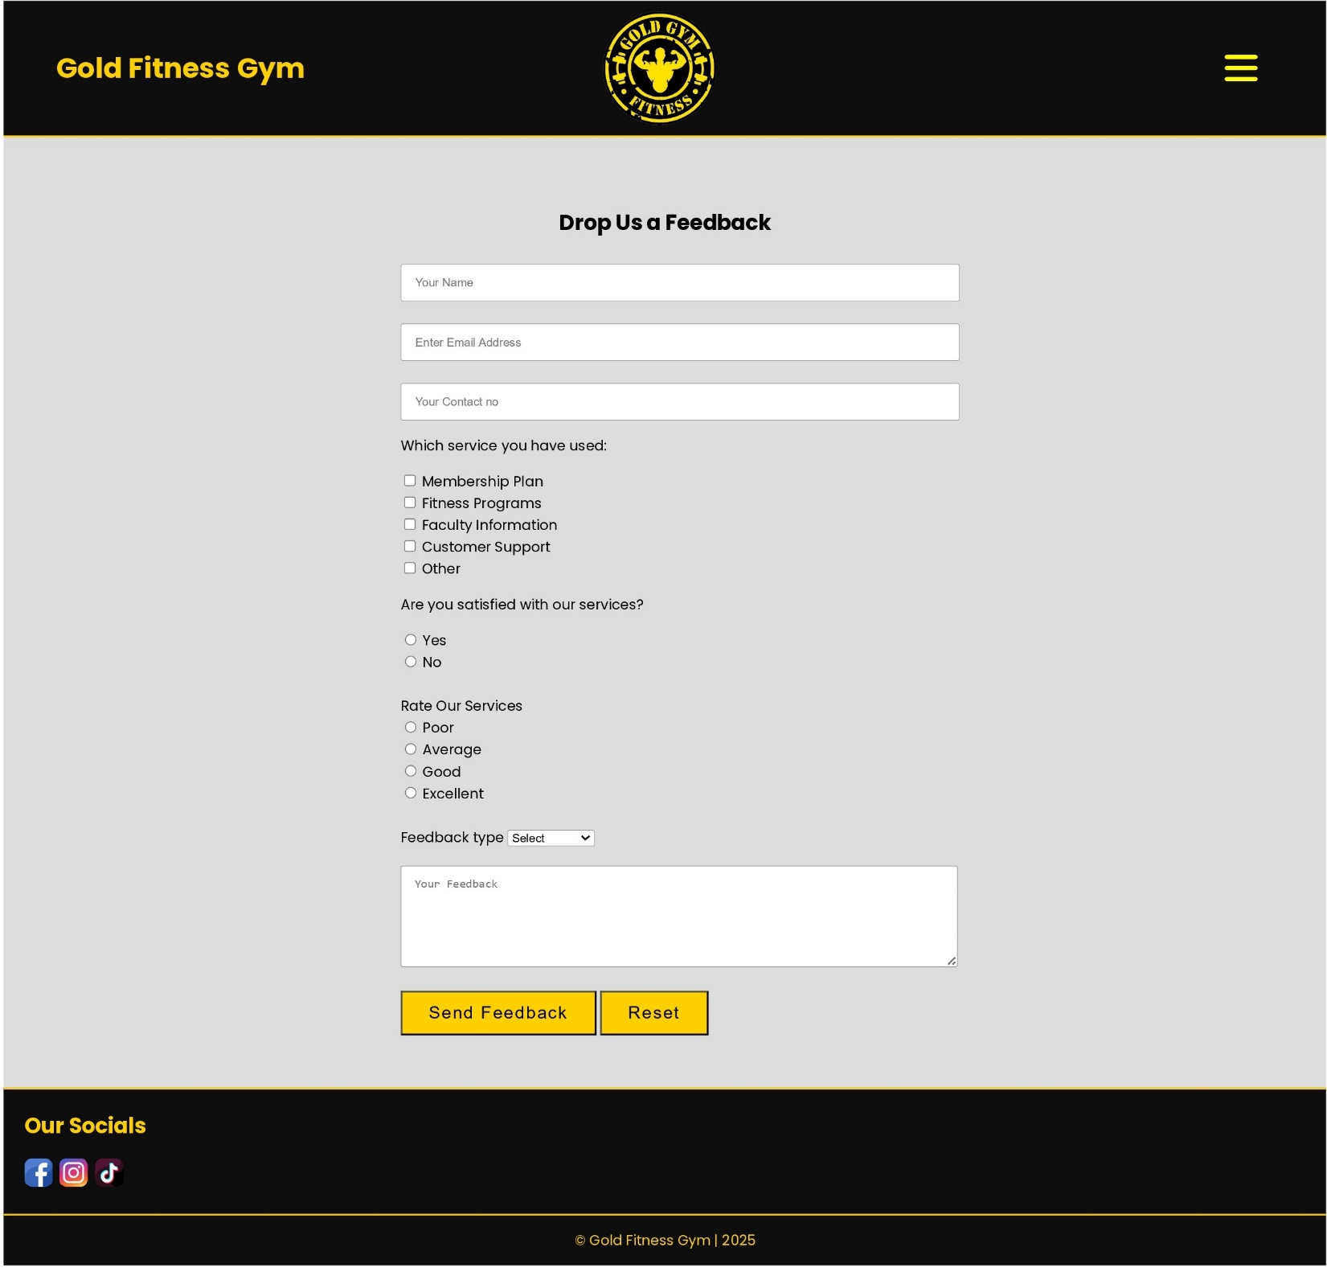

Website – Mandatory Sections:
- Home Page
  - Provide a main introduction to your website, including relevant images or videos.
- Website Logo
  - Display the logo designed in Task 1 on every page.
- About Page
  - Include detailed information about your website or business, such as vision and mission statements.
- Products Page
  - Present detailed information about the products related to your business.
- Services Page
  - Describe the services your business offers to customers.
- Blogs / Social Links
  - Add links to Facebook, Instagram, or other social media pages relevant to your business.
- Contact Page
  - Include your company’s address, contact details, and an embedded Google Map showing your location.
- Feedback Page
  - Create a feedback form to collect user input for improving your business.
  - The form should redirect users to a confirmation or linked page upon submission.
- Additional Sections
  - Add Header and Footer elements and any other relevant pages as needed.
  - Ensure that each tab or link navigates correctly to a new or detailed page.

Website – Technical Requirements:

- Use CSS to enhance the styling and overall visual appearance of your website.
- Include a proper Title Tag for the website.
- Place the graphic title or logo (from Task 1) at the top of every page.
- Assign a page title within the <head> section of each HTML file.
- Include structured content using tags such as <p>, <h1>–<h6>, <br>, and <img>.
- Ensure internal hyperlinks for smooth navigation across all web pages.
- Add a navigation bar or dropdown menu for user-friendly movement between pages.
- Provide at least one external hyperlink (absolute URL) that opens in a new browser tab or window.
- Include at least one numbered or bulleted list on your website.
- Create a 5×5 table (with column and row spans) and format it using CSS.
- The feedback form must include: an HTML form titled “Customer Feedback Form”. The form should include the
following fields and elements:
  - Name (text input)
  - Email (text input)
  - Rate Our Service (radio buttons: Excellent / Good / Average / Poor)
  - Services Used (checkboxes: Product Purchase / Delivery / Support / Other)
  - Feedback Type (dropdown: Suggestion / Complaint / Appreciation)
  - Comments (text area for user message)
  - Submit and Reset buttons
  - Use labels for all fields.
  - Group related elements using <fieldset> and <legend>.
  - Style the form using CSS to make it neat and readable (optional).
- You may add additional design elements such as CSS and Java Script cursor effects, form validation, animations, or transitions to enhance interactivity.

